HR ATTRITION ANALYSIS

Dataset:
11,991 rows × 10 columns
SatisfactionLevel, Last Evaluation, Number of Projects, Average Monthly Hours, Time Spent In Company, Work Accident, Left, PromotionInLast5Years, Department, Salary

Data Cleaning
- Cleaned the Salary column by removing unwanted characters using SQL REPLACE()
- Verified no null values across all 10 columns
- Converted categorical columns (Department, Salary) for analysis
- Renamed columns for consistency (e.g., Employee_Left, Satisfaction_Level)

Overall Attrition Rate

SELECT
ROUND(AVG(Employee_Left) * 100, 2) AS Attrition_Rate
FROM hr_attrition;

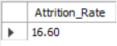

Result: 16.60%
Insight:
1 in 6 employees is leaving the company. A 16.60% attrition rate is considered high — industry benchmark is typically under 10%. This signals a serious retention problem that needs immediate attention.

Attrition by Department

SELECT
Department,
COUNT(*) AS Total_Employees,
SUM(Employee_Left) AS Employees_Left,
ROUND(AVG(Employee_Left) * 100, 2) AS Attrition_Rate
FROM hr_attrition
GROUP BY Department
ORDER BY Attrition_Rate DESC;

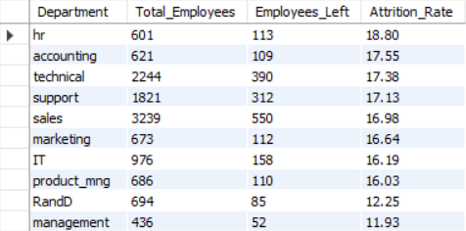

Result:
HR highest (18.80%), Management lowest (11.93%)
Insight:
HR and Technical departments are losing the most employees. This could be due to high stress, heavy workloads, or lack of growth opportunities in these departments. Management has the lowest attrition — likely because of better pay, authority, and job satisfaction.

Attrition by Salary Band

SELECT
Salary,
COUNT(*) AS Total_Employees,
SUM(Employee_Left) AS Employees_Left,
ROUND(AVG(Employee_Left) * 100, 2) AS Attrition_Rate
FROM hr_attrition
GROUP BY Salary
ORDER BY Attrition_Rate DESC;

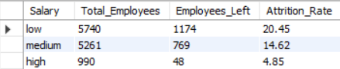

Result:
Low 20.45%,
Medium 14.62%,
High 4.85%
Insight:
Salary is the strongest predictor of attrition. Employees in the low salary band are 4x more likely to leave than high earners. This clearly shows that employees feel underpaid and are seeking better opportunities elsewhere.

Average Satisfaction: Left vs Stayed

SELECT
Employee_Left,
ROUND(AVG(Satisfaction_Level), 2) AS Avg_Satisfaction,
ROUND(AVG(Last_Evaluation), 2) AS Avg_Evaluation,
ROUND(AVG(Average_Monthly_Hours), 2) AS Avg_Monthly_Hours
FROM hr_attrition
GROUP BY Employee_Left;

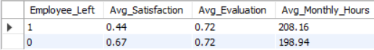

Result:
Left = 0.44 satisfaction,
Stayed = 0.67 satisfaction
Insight:
Employees who left had a satisfaction score of just 0.44 out of 1 — significantly lower than those who stayed (0.67). Low job satisfaction is a major red flag. Regular employee feedback and engagement programs could help catch dissatisfied employees early.

Workload vs Performance Analysis

SELECT
Employee_Left,
CASE
WHEN Average_Monthly_Hours > 210 THEN 'High Hours'
ELSE 'Normal Hours'
END AS Hours_Category,
ROUND(AVG(Last_Evaluation), 2) AS Avg_Evaluation,
ROUND(AVG(Satisfaction_Level), 2) AS Avg_Satisfaction,
COUNT(*) AS Total_Employees
FROM hr_attrition
GROUP BY Employee_Left, Hours_Category
ORDER BY Employee_Left DESC, Hours_Category;

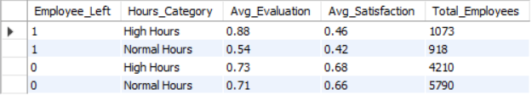

Result:
High hours leavers rated 0.88 but still left due to burnout
Insight:
This is the most alarming finding — the best performers (evaluation score 0.88) are leaving. They are not leaving due to poor performance but due to burnout from excessive working hours. Losing top talent is far more costly than losing average performers.

Overworked Employees

SELECT
COUNT(*) AS Overworked_Attrition
FROM hr_attrition
WHERE Average_Monthly_Hours > 250
AND Number_of_Projects > 5
AND Employee_Left = 1;

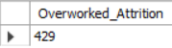

Result:
429 Employees

Insight:
Employees working more than 250 hours/month while handling more than 5 projects simultaneously have a significantly higher chance of leaving. Overworking employees beyond a healthy limit is counterproductive — it drives away the most hardworking people in the organization.

Power BI Dashboard

Charts Created:
- Attrition Count (Bar Chart) — Total employees who stayed vs left
- Attrition by Department (Clustered Bar Chart) — Attrition rate across all 10 departments
- Attrition by Salary Band (Bar Chart) — Comparison of Low, Medium, and High salary attrition
- Satisfaction Level Distribution — Satisfaction scores for employees who left vs stayed
- Average Monthly Hours vs Attrition — Workload analysis for leavers vs stayers
- Promotion in Last 5 Years (Donut Chart) — How many leavers had no promotion

Slicers Added:
Department | Salary Band | Left / Stayed

Key DAX Measure:
Attrition Rate = DIVIDE(COUNTROWS(FILTER(HRAttrition, HRAttrition[Left] = 1)), COUNTROWS(HRAttrition)) * 100

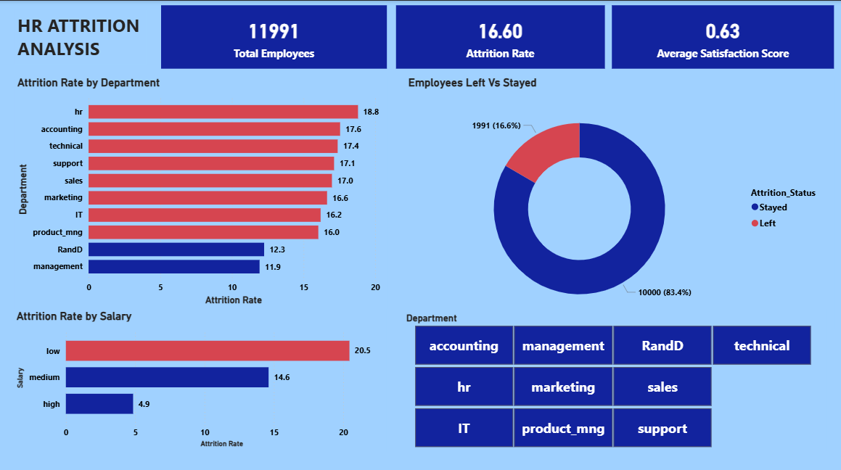

Key Insights & Recommendations

Key Findings:
- Overall attrition rate is 16.60% — 1 in 6 employees is leaving
- HR department has the highest attrition at 18.80%
- Low-salary employees are at highest risk (20.45% attrition)
- Burnout is a major driver — top performers working >250 hours/month are leaving despite high evaluations (0.88)
- Low satisfaction (0.44) strongly predicts attrition vs stayed employees (0.67)
- 429 overworked employees left — those handling >5 projects and >250 hours/month

Recommendations:
- Improve compensation for low-salary bands — biggest lever to reduce attrition
- Address HR department concerns — review workload and management quality
- Monitor overworked employees — implement project load limits (max 5 projects)
- Run regular satisfaction surveys — use scores as an early warning system
- Reward and retain high performers — employees with high evaluations need better recognition and growth opportunities

